Setup nodemon for express project: make following changes to package.json file:

1. Change main, which serves as entry point to your application to app/server.js (or whatever is appropriate for your project.
   1. 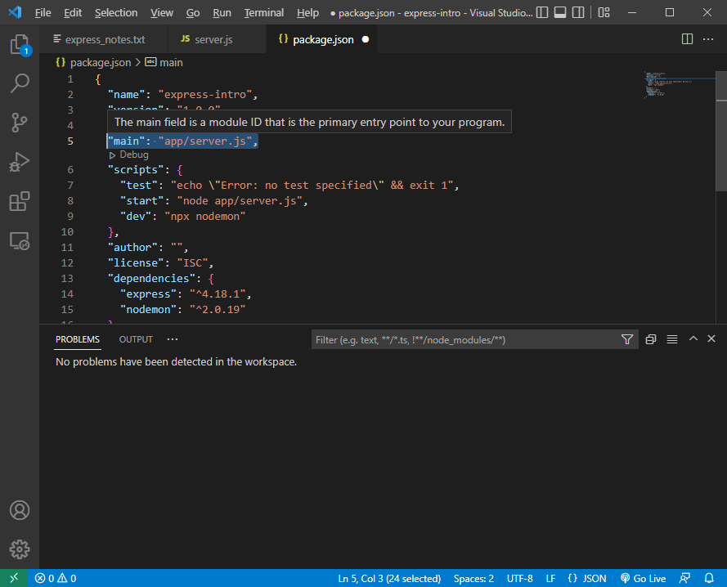

2. Under ‘scripts’ add a ‘start’ script w/ the following (or whatever is appropriate for your project)

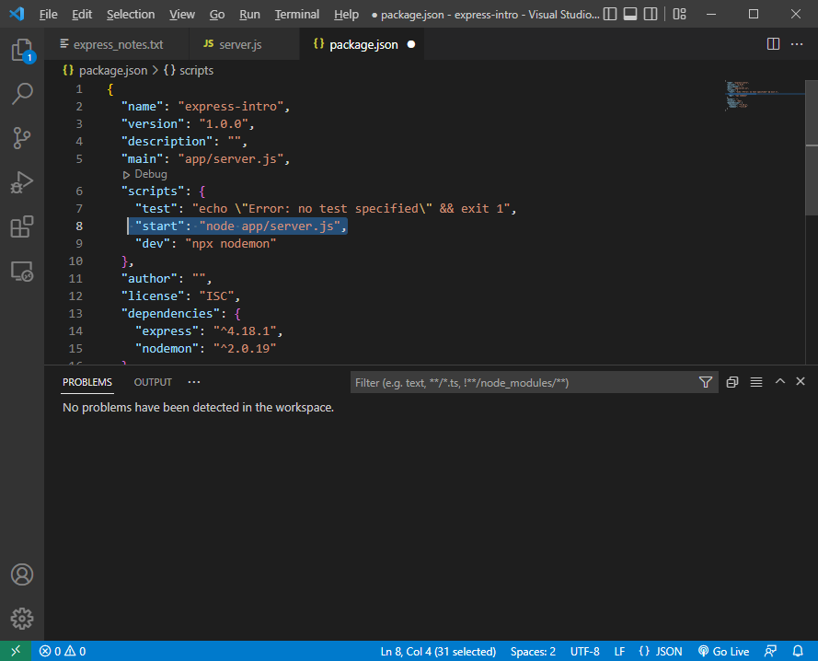

1. After installing nodemon via npm, under scripts add a “dev” script as follows
   1. 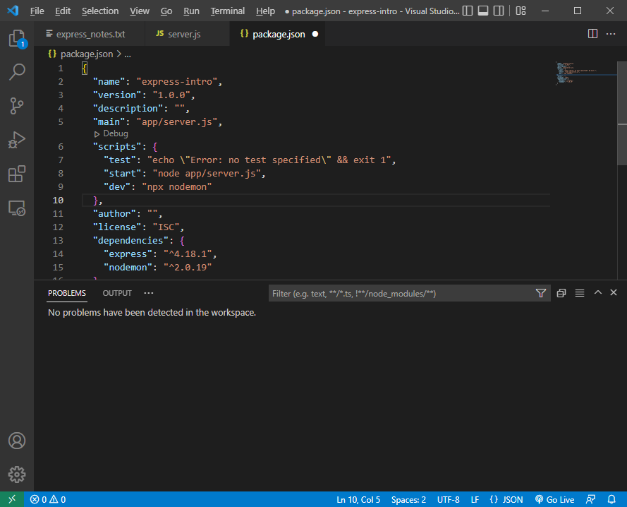
2. Package.json should look like (or similar to) this:
   1. 